Experiment – 9
Blueprint
Designing a Process Blueprint in Zoho Creator
Department of Computer Science and Engineering
Student Name : SANDEEP K
Roll No: 240701464
Application Name: Parking Slot Reservation(Purchase Request / Procurement Application)

Objective
To model a multi-step business process in Zoho Creator using a Blueprint, by defining the stages a record passes through and the transitions that move it from one stage to the next, and to apply it to the approval process of purchase requests.

Introduction
A Blueprint in Zoho Creator is a visual tool for designing and enforcing a process. Instead of allowing a record to be edited freely, a blueprint fixes the sequence in which the record must travel: the record is always in exactly one stage, and it can leave that stage only through a defined transition. Each transition appears to the user as a button, and conditions, field updates, notifications, and approvals can be attached to it. A blueprint therefore guarantees that every record follows the same approved path, and the history of the path taken is recorded.

Blueprint Components
Component | Description | In this Experiment
Blueprint | The complete process definition attached to a form | Approval blueprint, on the Approval History form
Stage | A state in which a record can be at any given time | Submitted, HOD Review, Finance Review, Procurement, Approved, Rejected, Revision Requested
Transition | The action that moves a record from one stage to another, shown as a button | Submit for HOD Review, Approve to Finance, Reject, Request Revision, Final Approval, Resubmit
Start | The entry point of the process | Start → Submitted
Table 9.1: Components of a Zoho Creator Blueprint.

Blueprint Design – Approval Workflow
The blueprint was designed for the approval process of a purchase request. A request starts at Submitted, passes through departmental (HOD) review and Finance review, and ends at Procurement and finally Approved. At each review stage the reviewer may also reject the request or send it back for revision, after which it can be resubmitted.
Stage | Transition | Next Stage | Type
Start | — | Submitted | Entry
Submitted | Submit for HOD Review | HOD Review | Forward
HOD Review | Approve to Finance | Finance Review | Forward
HOD Review | Reject | Rejected | End
HOD Review | Request Revision | Revision Requested | Return
Finance Review | Approve to Procurement | Procurement | Forward
Finance Review | Reject | Rejected | End
Finance Review | Request Revision | Revision Requested | Return
Procurement | Final Approval | Approved | End
Procurement | Reject | Rejected | End
Table 9.2: Stages and transitions of the Approval blueprint (as listed in the Transitions tab). The Resubmit transition, shown on the canvas, returns a revised request to the process.

Screenshot-based lab record
The following pages contain the actual Zoho Creator screenshots of the blueprint configuration.

Screenshots 1 – Blueprint List
The Blueprints tab of the Workflow section lists the blueprints of the application, grouped by form. The Approval History form appears under Forms with Blueprints and holds one blueprint, Approval blueprint, which is Enabled. The remaining forms — Budget, Department, Purchase Request, Purchase Request Items, and Vendor — appear under Forms without Blueprints.
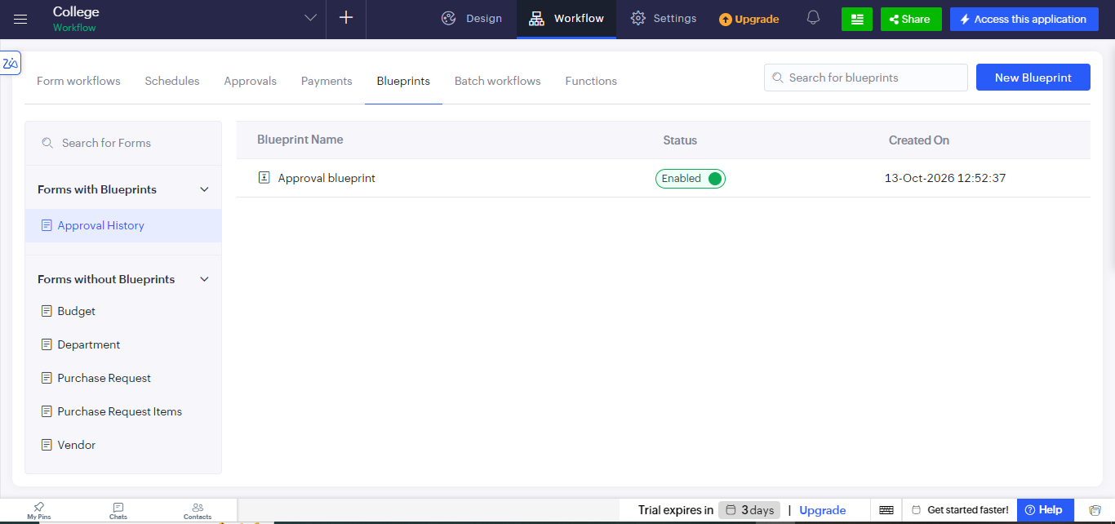
Figure 1: Blueprints tab showing the enabled Approval blueprint on the Approval History form.

Screenshots 2 – Blueprint Designer and Stages
The blueprint is drawn on a canvas that begins at a Start node. The right-hand panel has a Stages tab and a Transitions tab. The Available Stages list holds stages that have been defined but not yet placed on the canvas, and new stages are created with Add Stages.
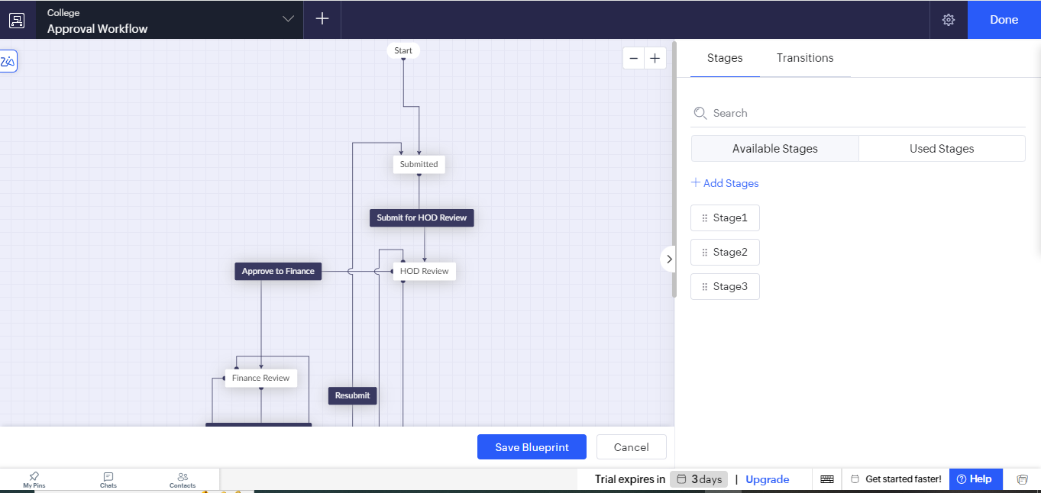
Figure 2.1: Blueprint designer — the canvas flow from Start to Submitted, HOD Review, and Finance Review, with unused stages (Stage1, Stage2, Stage3) under Available Stages.
The Used Stages list shows every stage that has been placed on the canvas. Seven stages are used by the Approval workflow: Approved, Finance Review, HOD Review, Procurement, Rejected, Revision Requested, and Submitted.
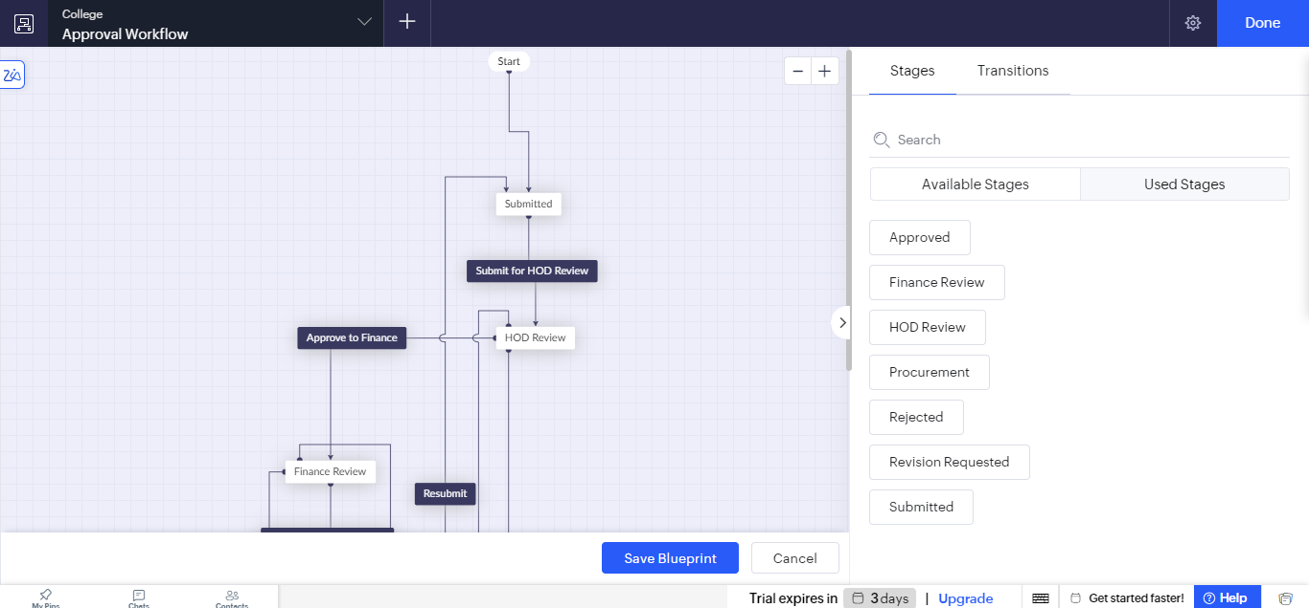
Figure 2.2: Used Stages of the Approval blueprint.

Screenshots 3 – Transitions
The Transitions tab lists each transition as the stage it starts from, the transition button name, and the stage it leads to. These are the actions the reviewer sees on a record while it is in that stage.
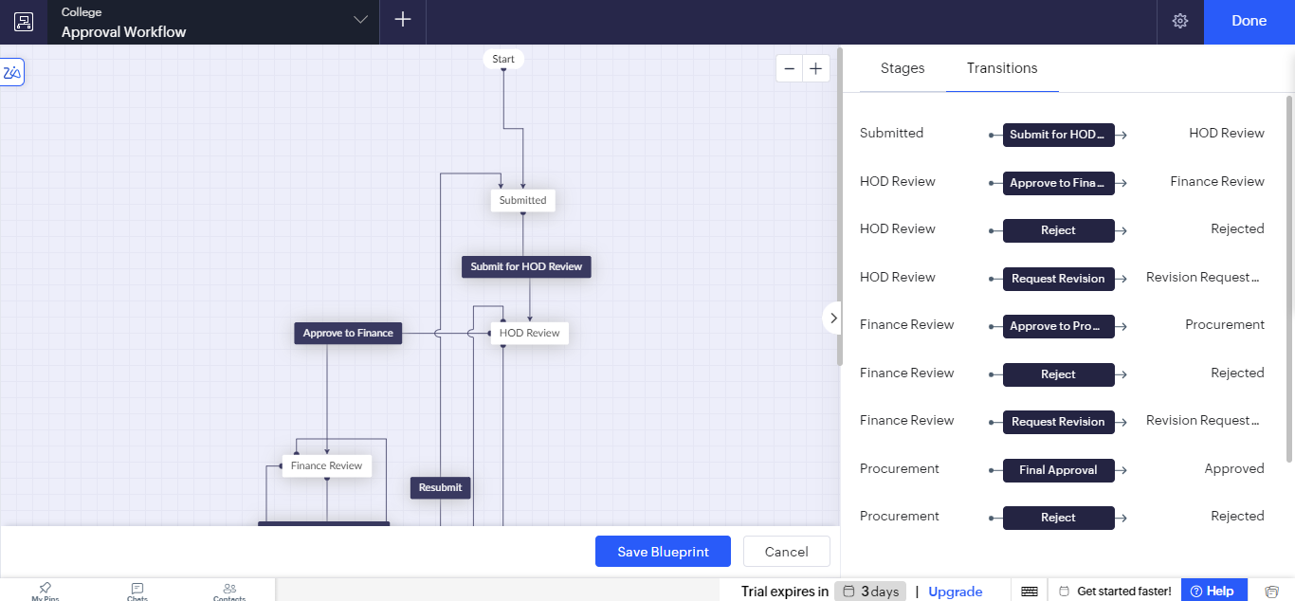
Figure 3: Transitions tab listing the transitions between stages of the Approval blueprint.

Observation
The purchase approval process was captured as a diagram of stages and transitions, and no code was needed to define the routing. A request can only move along the connections drawn on the canvas, so, in the transitions listed, a request cannot reach Procurement without passing through both HOD Review and Finance Review. Each review stage offers three outcomes — approve and move forward, reject, or request a revision — and the Resubmit transition lets the requester correct a returned request and send it through the process again. Because the process is drawn rather than coded, it is easy to read, to explain to non-technical users, and to change by adding a stage or a transition.
A blueprint differs from the form workflows of Experiment 8 in an important way. A form workflow reacts to an event after it happens, whereas a blueprint controls what the user is allowed to do next, which makes it suitable for processes that must be followed in a fixed order.

Result
A Blueprint named Approval blueprint was successfully created and enabled in the Zoho Creator application. It defines seven stages and a set of transitions covering submission, HOD review, Finance review, procurement, final approval, rejection, and revision of purchase requests, and thereby enforces a uniform approval process.

